**CN LAB 7 REPORT**

**Enable and Configure RIP Version 1 (RIPv1):-**

**Creating a Network Topology for RIP / RIPv1 in Packet Tracer :-**

If you’re starting, Packet Tracer has a really easy-to-use interface to do this. So, when you are ready, launch it and set up a network like the image below.

But keep in mind that RIP is common in small and medium-sized networks. But, even though it’s an old method, it’s still good for you to understand.

To make a network like the picture, start by adding the devices:

* In the Device section, add two Router 1941 to the Logical workspace.
* Likewise, add two Cisco Switch 2960s.
* Lastly, add four PC-PTs.

To cable them in Packet Tracer, follow these steps:

* Link the two routers with a Serial DCE-DTE cable.
* Connect the GigabitEthernet ports of R1 and R2 Routers to the Switch (SW1/SW2) ports with a straight-through cable.
* Connect PC1 and PC2 to SW1, PC3, and PC4 to SW2 with a straight cable.

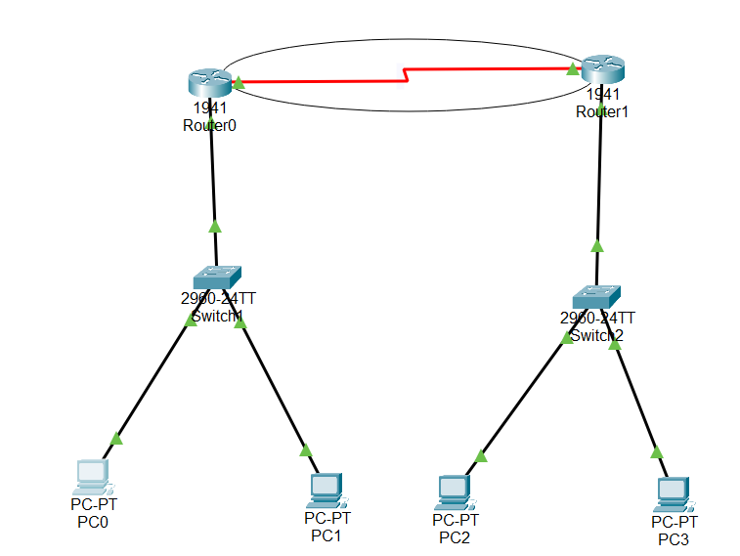

**1. Configuring GigabitEthernet and Serial Ports**

**Step 1 :-**

Click on the R1 Router you made in the setup, and open the settings. After that, go to the CLI tab. Use the commands below to give IP addresses to R1’s GigabitEthernet and Serial ports.

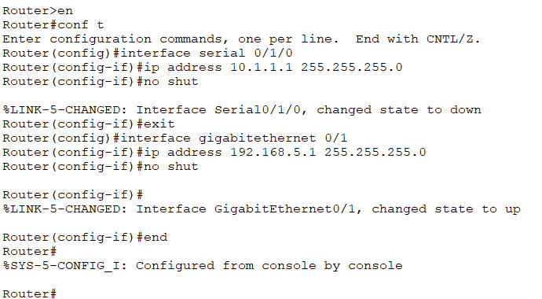

**Step 2:-**

Similarly, set up the Serial0/1/1 and Gig0/1 ports on Router R2 like this:

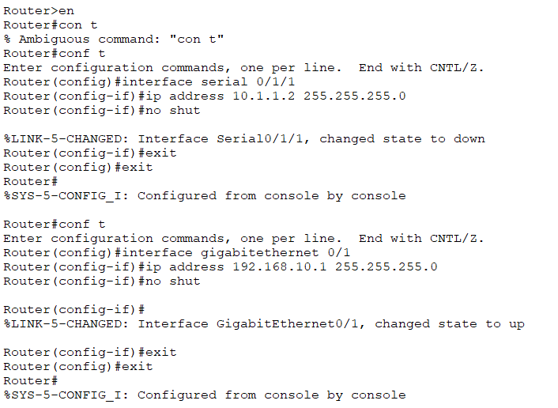

**Step 3:-**

You have assigned IP addresses to Routers R1 and R2. Now, before enabling RIP, test the connection by pinging devices on LAN2 from LAN1.

Your connection from PC1 to R1’s GigabitEthernet and Serial IPs will be smooth. Because of that, PC1 and PC2 are on the same network as Router R1.

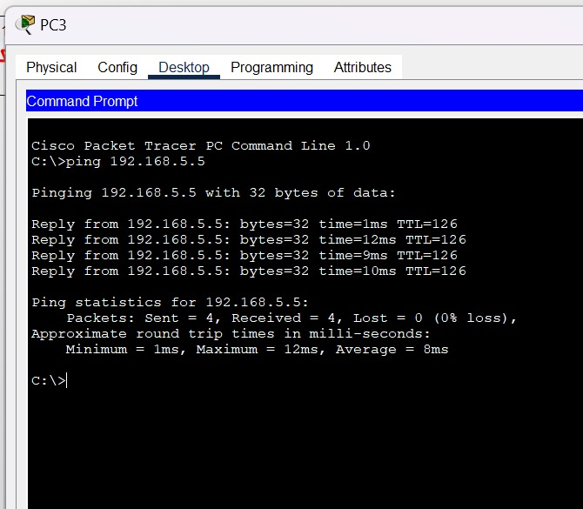

**Enabling RIP Configuration**

**Step 1:-**

Now, we want the PCs in LAN1 and LAN2 to talk to each other. To make this happen, let’s turn on the RIP routing protocol on the Cisco Router R1 and R2 network devices.

Start by opening the R1 device’s CLI, then use the commands below to turn on RIP.

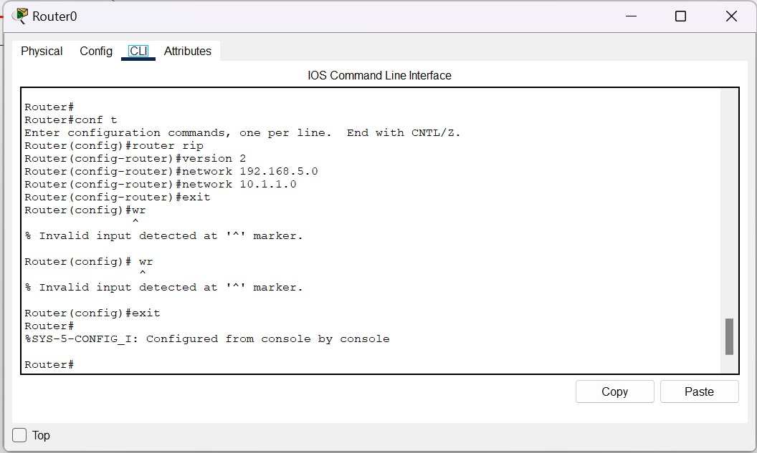

**Step 2:-**

You should apply the same steps to R2 as you did to R1. Now, follow these commands to set up RIP on R2:



**Step 3:-**

This step is up to you. You can decide how quickly RIP updates happen. Also, you can choose how long to keep the route valid and for how long.

This step makes the network work better.

[The order of the command is like](https://www.cisco.com/E-Learning/bulk/public/tac/cim/cib/using_cisco_ios_software/cmdrefs/timers_basic.htm): timers basic “update time” “invalid time” “holddown time.”

**a) show ip route**

**Step 1:-**

Once you’ve set up RIPv1, R1 and R2 devices can chat with each other. So they will share details about the networks you add with others. Now, check these routes by using the “show ip route” command.

The result of the “show ip route” command on R1 looks like this:



Looking at the picture, you can find the entry “R – 192.168.10.0/24 (120/1) via 10.1.1.2, 00:00:14, Serial0/1/0”. Here’s what this route record means:

* **R:** It means RIP is OK.
* **168.10.0/24:** It shows the target network and [CIDR](https://www.sysnettechsolutions.com/en/what-is-cidr/).
* **120/1:** The first number (120) indicates the metric value. The second number (1) shows the distance to the referral source.
* **via 10.1.1.2:** It is the IP address of the Router used to reach the routing entry.
* **00:00:14:** This tells us that it learned this routing info just 14 seconds ago.
* **Serial 0/1/0:** It shows the output port used to reach the target.

**Step 2 :-**

* Likewise, check the routing routes on Router R2. For this, run “show ip route.”

**Step 3 :-**Now that you have RIP set up, try testing the connection by pinging the target network from PC1. Before, the ping didn’t work, but now Routers can talk to each other directly.

Now, ping R2’s Serial port from PC1 and Ping PC3 and PC4 on its subnet. As shown in the image, users on LAN1 can now access LAN2.

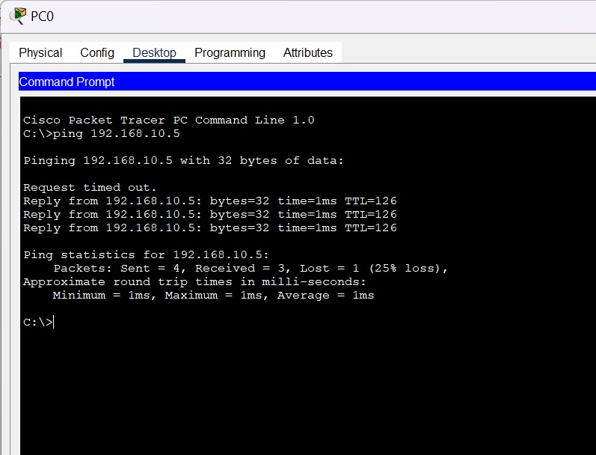

**Step 4 :-** PCs on the 192.168.10.0/24 network can also access 192.168.5.0/24, that is, LAN1, without any problems.

**Show ip protocols**

**Step 1 :-**

Also, you can figure out which Routing protocol is in use on the Router by using “show ip protocols.” If you run it in the CLI of the R1 device, you’ll get a notice like the one below.

The result of the command shows that the routing protocol is “rip.”

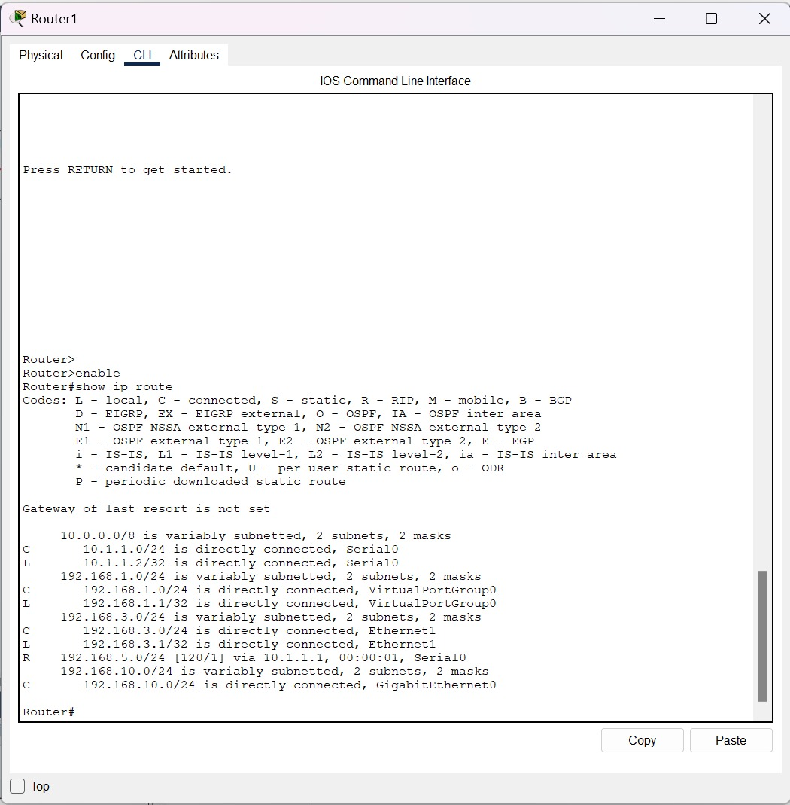

**Step 2 :-**

Likewise, you can check which routing the R2 has.

**Step 3 :-**

You can also see detailed routes with the “show ip rip database” command on R1.